 | 16.3 Editors - Dope Sheet - Sidebar
Table of content
Sidebar - Custom Properties 2
Add 2
Edit 2
Remove 2
Sidebar - Action panel 2
Manual Frame Range 2
Start / End 2
Cyclic Animation 2
Sidebar - Layer panel 2
Blend 3
Opacity 3
Lights 3
Masks subpanel 3
Enable 3
Layer Specials 3
Mask layer list 3
Layer name 3
Invert 3
Hide 3
Search 3
Invert 3
Resize 3
Transform subpanel 4
Adjustment subpanel 4
Tint color 4
Factor 4
Stroke Thickness 4
Relations subpanel 4
Parent 4
Type 4
Display subpanel 4
Custom channel color 4
Show only on keyframed 4
Sidebar - Create Pose Asset panel 5
Create Pose Asset 5
Pose name 5
Library 5
Catalog 5
Copy Pose as Asset 5

Sidebar - Custom Properties

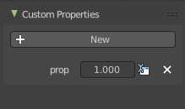
Here you can define custom properties that can be used for scripting.

Add
Adds a new property.

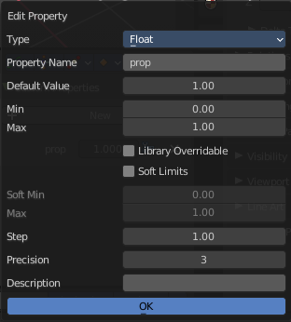
Edit
Opens a panel where you can adjust the settings for the custom property.

Remove
Removes the property.

Sidebar - Action panel

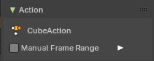
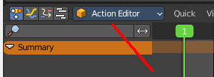
In Dope Sheet and Action Editor sub mode.

Manual Frame Range
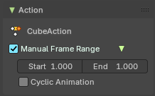
Use a manual frame range.

Start / End
The start and end frame of the manual range.

Cyclic Animation
If the animation in the manual frame range should cycle.

Sidebar - Layer panel

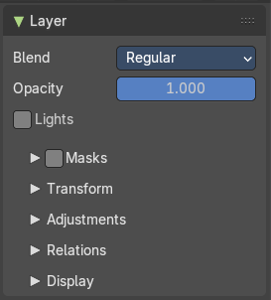
Grease Pencil mode only. This panel contains further settings for the grease pencil layers. And also exists with nearly same content in the properties editor in the object data properties tab when you have a grease pencil object selected.

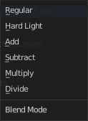
Blend
The blend mode for the current layer.

Opacity
The layer opacity.

Lights
Enable the use of lights on stroke and fill materials.

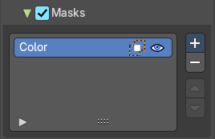
Masks subpanel
Use masking.

Enable
Activate the use of masks. Every existing grease pencil layer can be used as mask.

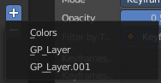
Layer Specials
Choose the grease pencil layer that you want to add and use as a mask.

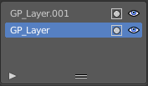
Mask layer list
The list of the mask layers.

Layer name
The name of the layer. Double clicking at it enables to edit the name.

Invert
Invert the mask.

Hide
Show or hide the mask.

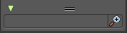
Search
At the end of the list you will find a search field. It can be revealed by clicking at the triangle button. Type in the term that you want to search for.

Invert
Inverts the filtering of the content.

Resize
The list can be resized by the handler with the two lines at the bottom.

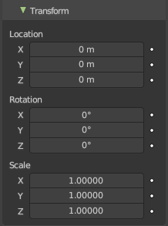
Transform subpanel
Transform values.

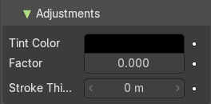
Adjustment subpanel

Tint color
Color for tinting stroke colors.

Factor
Factor of tinting color.

Stroke Thickness
Radius change to apply to current strokes.

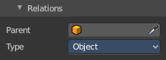
Relations subpanel

Parent
Parent object.

Type
The object type to parent to.

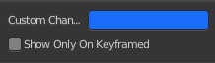
Display subpanel

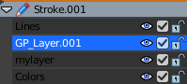
Custom channel color
Give the selected channels another color in the channels list.

Show only on keyframed
In Paint mode display only layers with keyframe in current frame.

Sidebar - Create Pose Asset panel

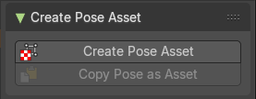
This panel just shows when you have a armature selected and when you are in pose mode in the 3d view.

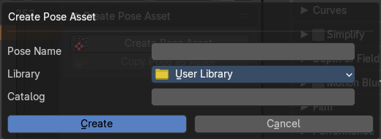
Create Pose Asset
Creates a pose asset from the selected armature in pose mode. It opens a dialog. The dialog is pretty self explaining.

Pose name
Name of the pose.

Library
The library where you want to store the pose.

Catalog
Catalog to use for the new asset.

Copy Pose as Asset
Copies the current pose of the selected armature as an asset. You can then paste it into the asset library.

